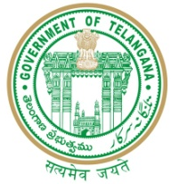

GOVERNMENT OF TELANGANA
TELANGANA TRIBAL WELFARE RESIDENTIAL DEGREE COLLEGE FOR GIRLS, MAHABUBABAD: MAHABUBABAD-DIST
https://www.ttwrdcs.ac.in/Mahabubabad
E-Mail Id:ttwrdcgirls.mahabubabad@gmail.com Cell No: 7901097695

CIRCULAR
Rc. No. Spl/IQAC Committee/017 Dated: 20.06.2018
The Internal Quality Assurance Cell (IQAC) of TTWRDC (G), MAHABUBABAD has been constituted with the following members.
IQAC COMMITTEE
1 | Madar sahib | Principal | Chairman
2 | T.Swapna | Asst.Professor in Physics | Coordinator
3. | A.Rajini | Asst.Professor in Mathematics | Member
4. | Shushma | Asst.Professor in commerce | Member
5 | M.Narmada | Asst.Professor in chemistry | Member
6 | D.Rajini | Asst.Professor of Computer Science | Member
7 | K.Somashankaraiah | Administrative Officer | Member
8 | D.Raju | Principal GDC Mahabubabad | Member
9 | L. Roopsingh | Parent | Member

